|  |  |
| --- | --- |
| Name : Jade Ryan L. Blancaflor | Section : BSIT 3C |
| Assignment No : 2 | Submission Date : |
| Assignment Title: Rock - Paper - Scissors | |

**Code :**

**HTML FILE**

*// insert code*

<!DOCTYPE html>

<html>

<head>

<meta charset="utf-8">

<meta name="viewport" content="width=device-width, initial-scale=1">

<title> Rock - Paper – Scissors </title>

<link rel="stylesheet" href="style.css">

</head>

<body>

<section class="container">

<article class="box">

<h1>Rock - Paper - Scissors</h1>

<div class="text">

<h3>Choose your pick!</h3>

</div>

<div class="pick">

<button onclick="play('rock')">✊</button>

<button onclick="play('paper')">🖐</button>

<button onclick="play('scissors')">✌</button>

</div>

<div class="score">

<div class="player">

<p>PLAYER</p>

<span id="playerdisplay"></span>

</div>

<div class="cpu">

<p>COMPUTER</p>

<span id="computerdisplay"></span>

</div>

</div>

<div id="result"></div>

<div class="scoredisplay"> Player Score:

<span id="playerscore"></span>

</div>

<div class="scoredisplay"> Computer Score:

<span id="computerscore"></span>

</div>

</article>

<div></div>

</section>

</body>

</html>

<script src="jscript.js"></script>

**JS FILE**

*// insert code*

const pick = ["rock", "paper", "scissors"];

const playerdisplay = document.getElementById("playerdisplay");

const computerdisplay = document.getElementById("computerdisplay");

const resultDisplay = document.getElementById("result");

const playerscoredisplay = document.getElementById("playerscore");

const computerscoredisplay = document.getElementById("computerscore");

let playerscore = 0;

let computerscore = 0;

function winner(playerpick, computerpick) {

if (playerpick === computerpick){

return "It's A tie"

} else if (

(playerpick === "rock" && computerpick === "scissors") ||

(playerpick === "paper" && computerpick === "rock") ||

(playerpick === "scissors" && computerpick === "paper")

) {

return "You Win!";

} else {

return "You Lose!";

}

}

function play(playerpick) {

const computerpick = pick[Math.floor(Math.random() * 3)];

const result = winner(playerpick, computerpick);

playerdisplay.textContent = playerpick;

computerdisplay.textContent = computerpick;

resultDisplay.textContent = result;

switch(result){

case "You Win!":

resultDisplay.classList.add("greenText");

playerscore++;

playerscoredisplay.textContent = playerscore;

break;

case "You Lose!":

resultDisplay.classList.add("redText");

computerscore++;

computerscoredisplay.textContent = computerscore;

break;

default:

resultDisplay.classList.remove("greenText", "redText");

}

}

function Solve(val){ //FOR SOlVING THE INPUT NUM1 AND NUM2, COMPARE THE TWO NUMBER

var v = document.getElementById('result');

v.value += val;

}

function Result(){

var num1 = document.getElementById("result").value;

try{

var num2 = eval(num1);

if (!isNaN(num2)){

document.getElementById('result').value = num2;

} else {

document.getElementById('result').value = 'Error';

}

} catch (error) { // It's for error input to double

document.getElementById('result').value = 'Error';

}

}

function Clear(){ // FOR ALL CLEAR INPUT TYPE

document.getElementById('result').value = '';

}

function Back(){ //FOR DELETE THE FIRST INPUT

var ev = document.getElementById('result');

ev.value = ev.value.slice(0,-1);

}

**CSS FILE**

*// insert code*

@import url("https://fonts.googleapis.com/css2?family=Poppins:wght@200;300;400;500;600;700&display=swap");

* {

margin: 0;

padding: 0;

box-sizing: border-box;

font-family: "Poppins", sans-serif;

}

body {

height: 100vh;

display: flex;

align-items: center;

justify-content: center;

background: #f6f7fb;

}

.container {

background-color: #17202A;

max-width: 80%; /* Use max-width instead of fixed width */

height: auto; /* Change height to auto for responsiveness */

text-align: center;

padding: 50px;

font-size: 1.6rem;

border-radius: 2%;

color: #f6f7fb;

box-shadow: 0 0 10px rgba(0, 0, 0, 0.3); /* Add a box shadow for better visibility */

}

.score {

display: flex;

flex-wrap: wrap; /* Allow flex items to wrap */

justify-content: center;

margin: 10px;

}

.pick {

margin: 35px;

}

.pick button {

border: 5px solid transparent;

font-size: 5rem;

border-radius: 50px;

min-width: 100px;

margin: 0 10px;

cursor: pointer;

background-color: #5DADE2;

transition: background-color 0.5s ease;

}

.pick button:hover {

background-color: white;

}

.player {

font-size: 1.1rem;

width: 100%;

max-width: 50%;

font-weight: 600;

}

.cpu {

font-size: 1.1rem;

width: 100%;

max-width: 50%;

font-weight: 600;

}

.text {

padding: 10px;

font-size: 1rem;

}

#playerdisplay{

font-size: 1.1rem;

font-weight: 100;

}

#computerdisplay{

font-size: 1.1rem;

font-weight: 100;

}

#result {

margin: 30px;

font-size: 2.5rem;

font-weight: 600;

}

.greenText{

color: green;

}

.redText{

color: red;

}

.scoredisplay{

font-size: 1rem;

}

**SCREENSHOT**

*// insert photo/image/screenshot of output*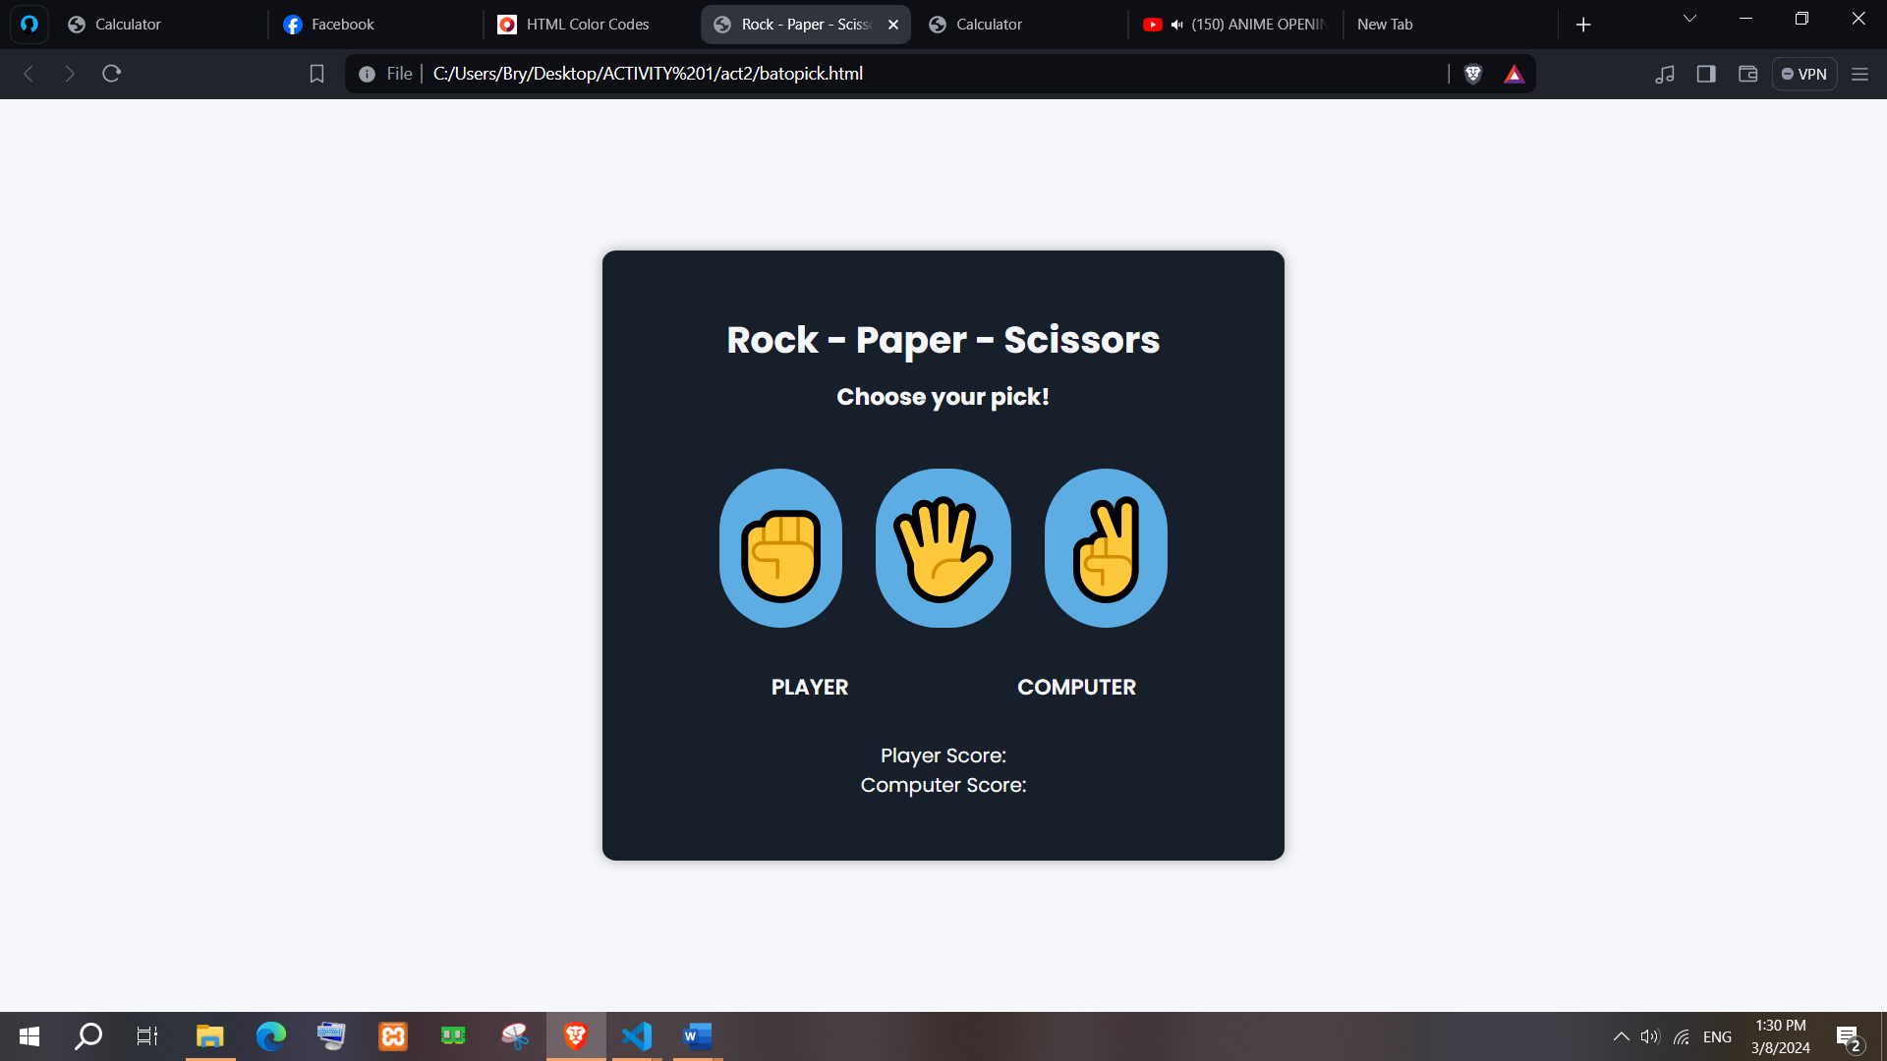

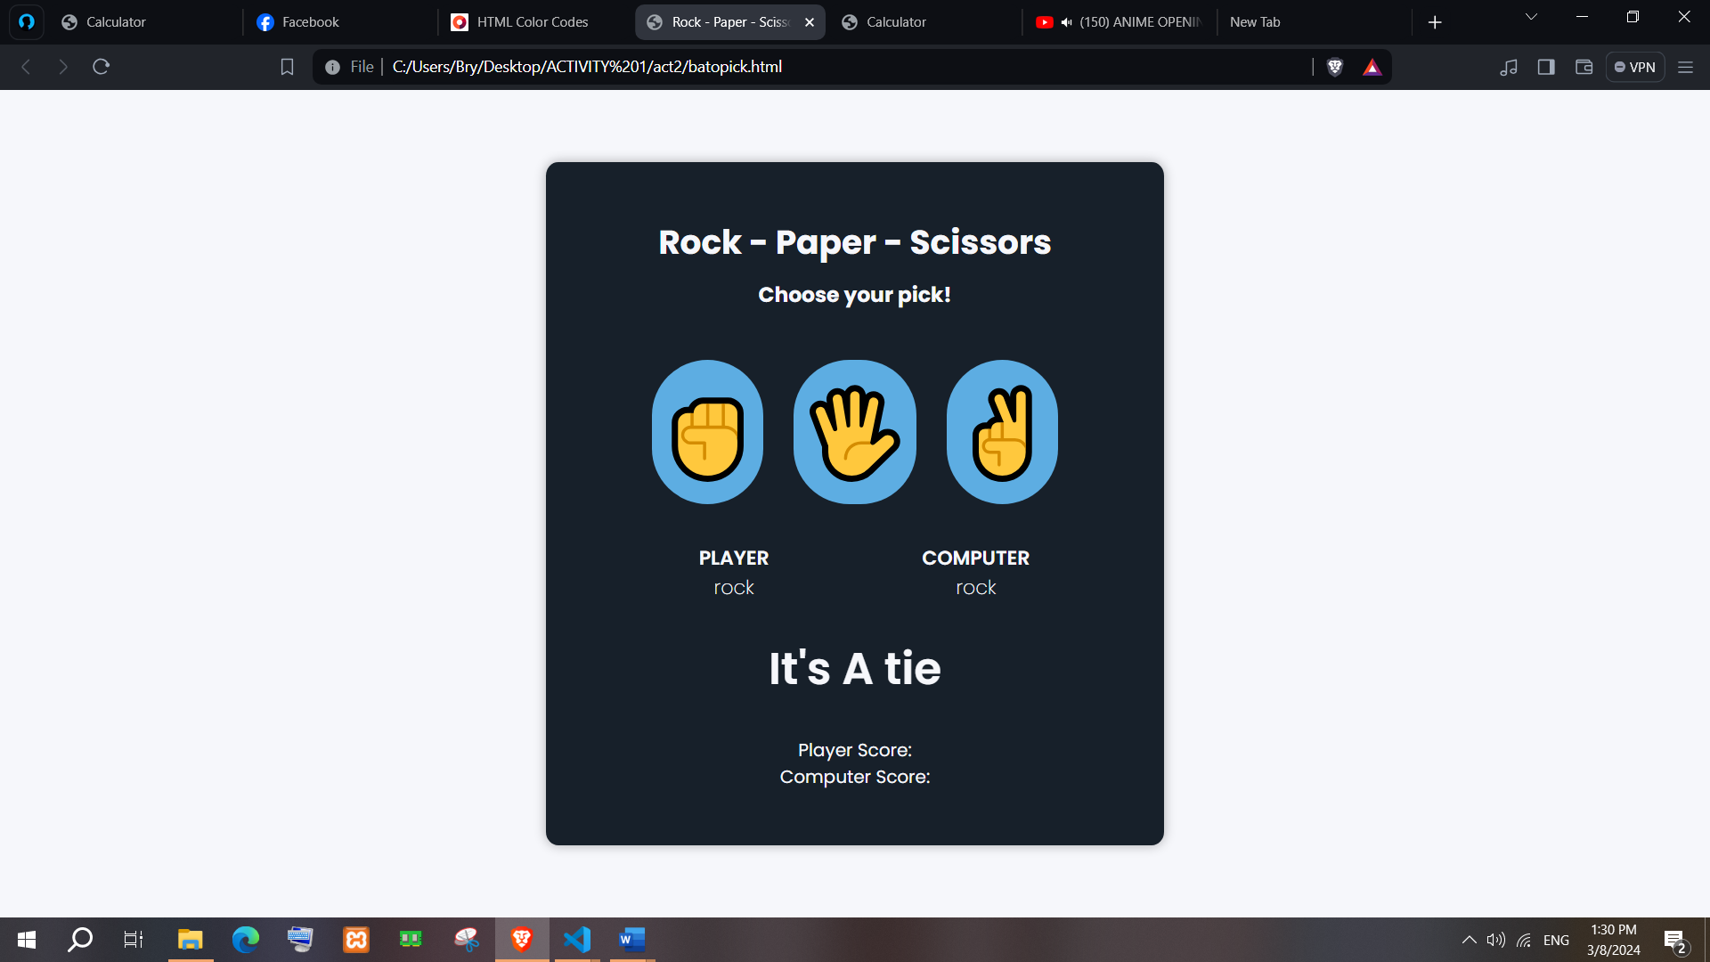

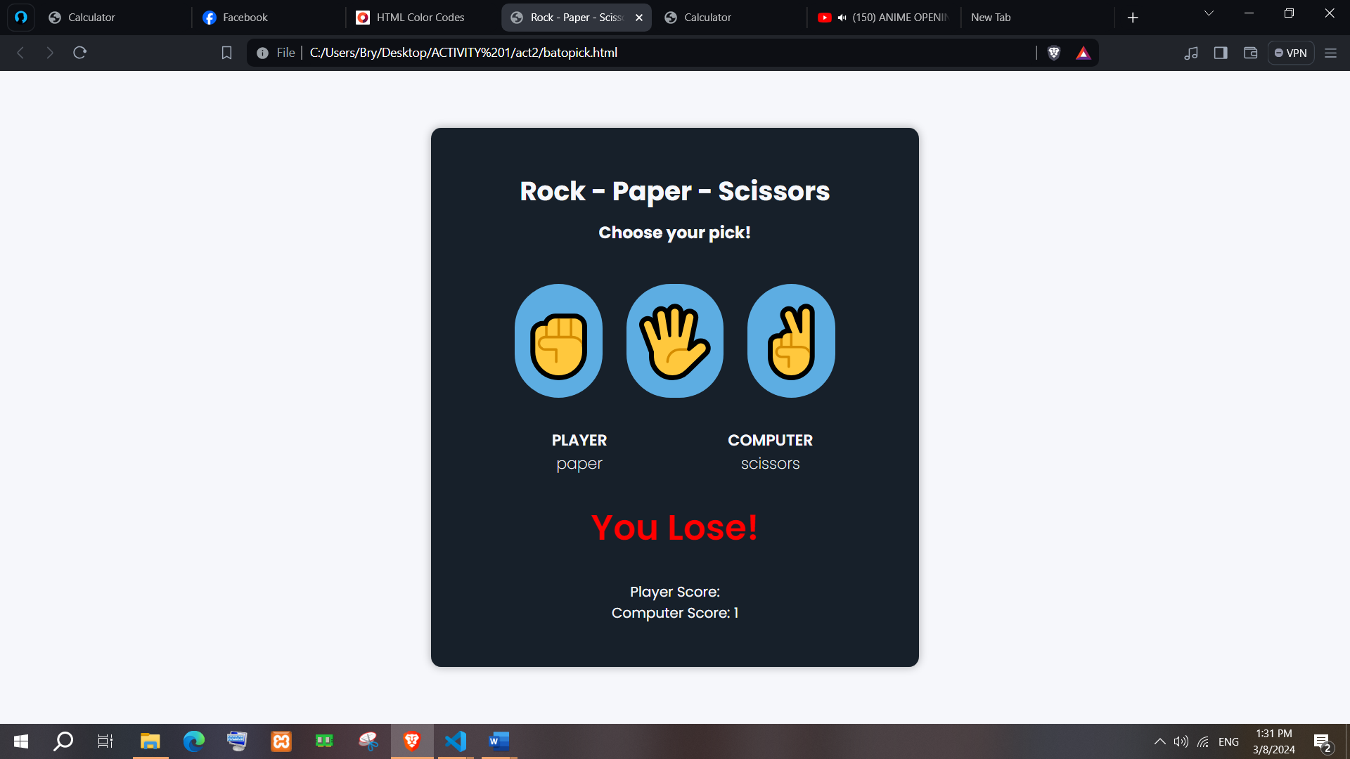

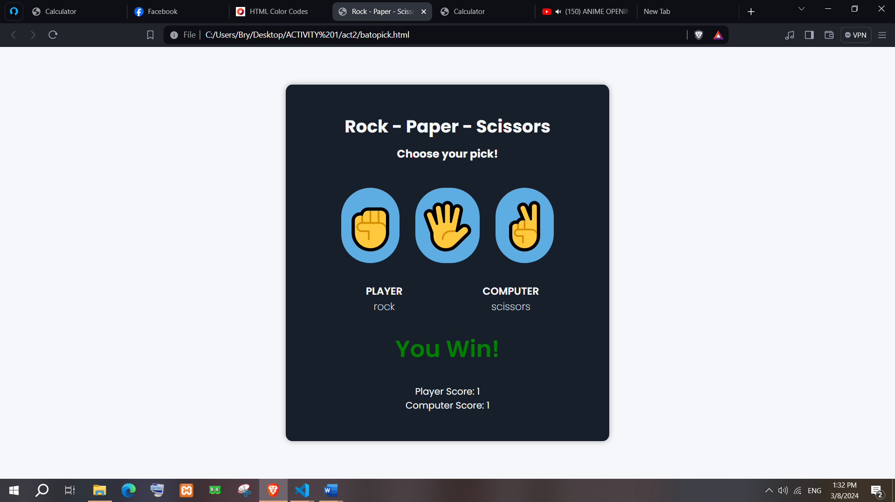

**Dictionary:**

*// List keywords, tags, or methods that are new to you and explain how they are used in the code.*

*// atleast 5 tag, methods or keyword*

* Const:
* Let
* document
* getElementById
* function
* return
* switch & case
* default
* &&
* ||

*Example :*

* **eval** - method evaluates the expression or computes the computation.

*Ex. ( insert the example : syntax / code / process )*

**Syntax** : eval(string)

**Parameter** : string (hold an expression, variable, statement, or sequence of statements.

console.log(eval(123+1+5))

Output : 129